W_gg search
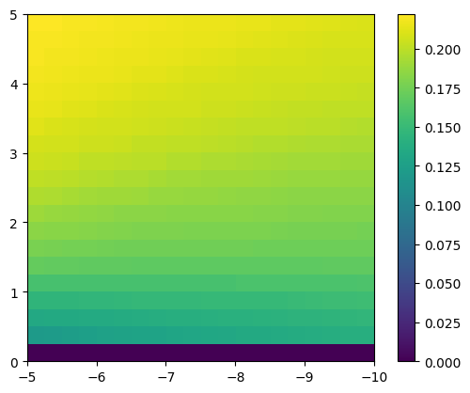
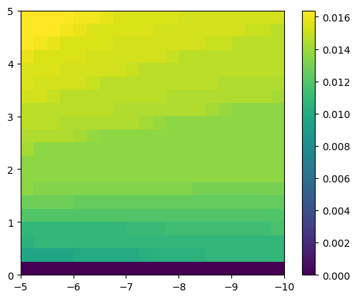
Grid only, g0 = noisy (value=2) g0 = noisy (value=4)

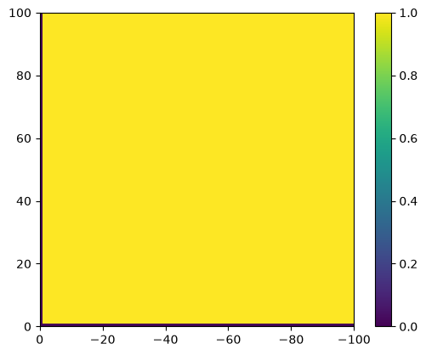
Full search, noise value = 0 noise value = 1 (values very close in the yellow region, 0.923 – 0.936)
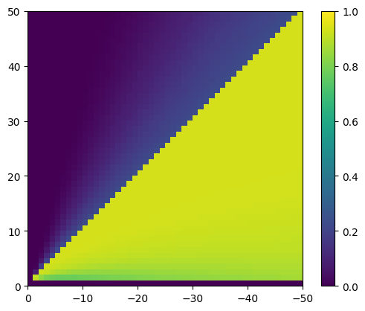

noise value = 2 noise value = 4
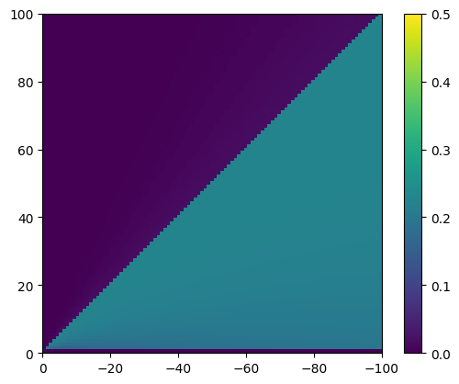
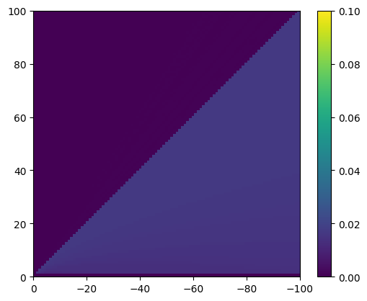

varying inh
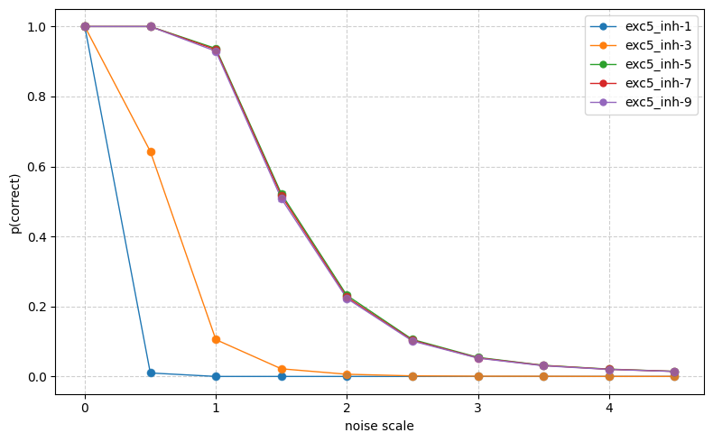
varying exc

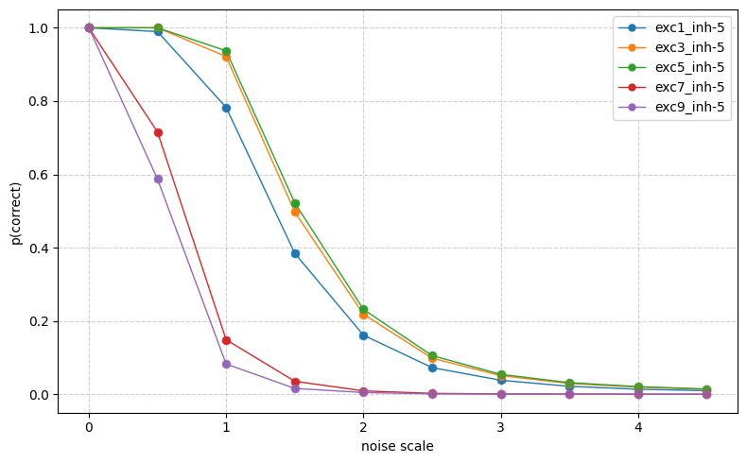

Scaffold parameter searches
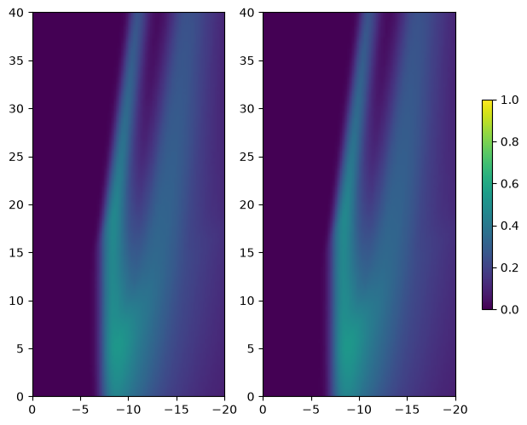
g0 = zeros, h0 = pattern, dt = 0.1
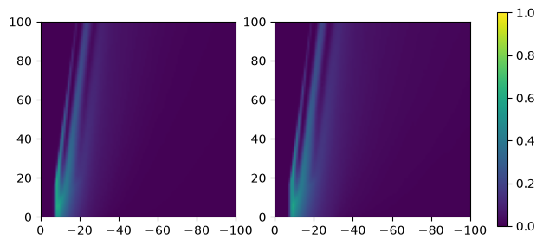

g0 = zeros, h0 = pattern, dt = 0.05
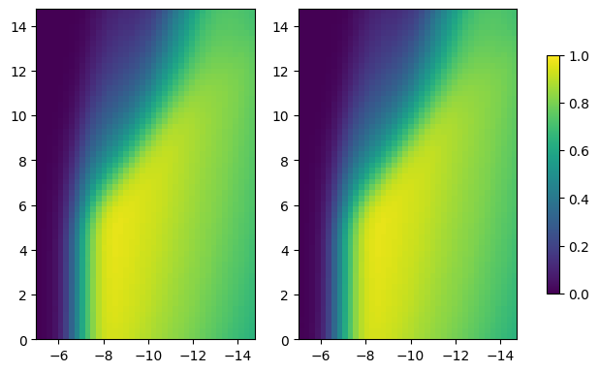
(max: 5, -10; finer: 4.5, -8.5)
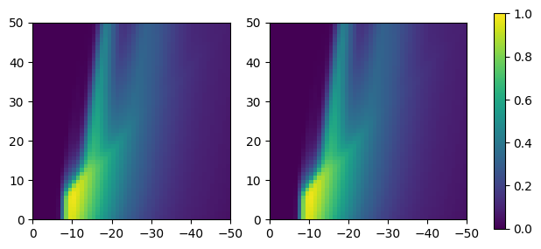
g0 = zeros, h0 = pattern, dt = 0.02
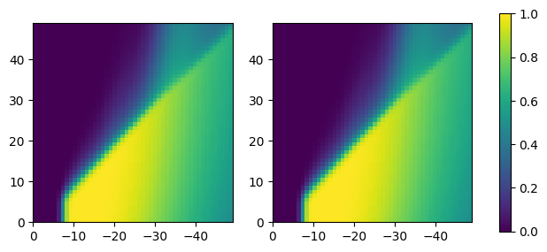

g0 = zeros, h0 = pattern, dt = 0.01
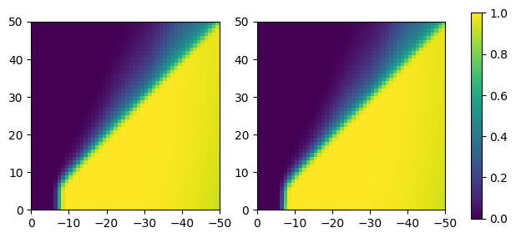

finer search:
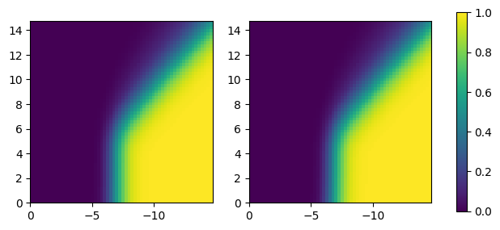

g0 = zeros, h0 = pattern, dt = 0.0075 g0 = zeros, h0 = pattern, dt = 0.005
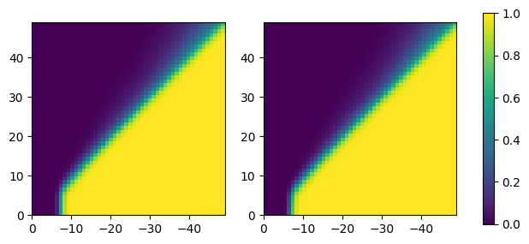
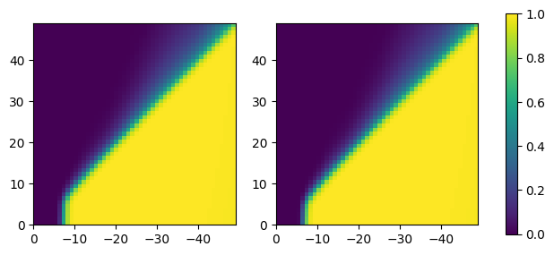

if sparsity of W_hg is 0: (sigmoid, g0, h0 = patterns)
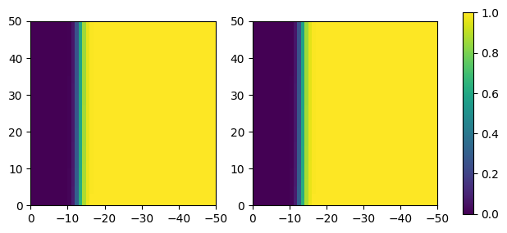

sparsity = 0.6 (sigmoid, g0, h0 = patterns)
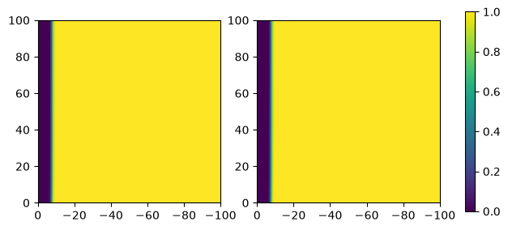

Failure modes (dt=0.01)
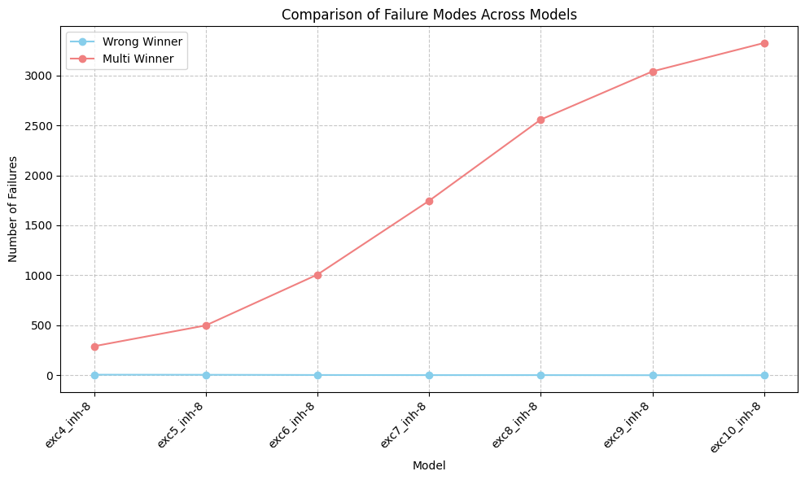

exc4_inh-8: frac_correct=0.918, wrong_winner=5, multi_winner=290
exc5_inh-8: frac_correct=0.861, wrong_winner=4, multi_winner=498
exc6_inh-8: frac_correct=0.720, wrong_winner=2, multi_winner=1007
exc7_inh-8: frac_correct=0.515, wrong_winner=1, multi_winner=1746
exc8_inh-8: frac_correct=0.289, wrong_winner=1, multi_winner=2559
exc9_inh-8: frac_correct=0.155, wrong_winner=0, multi_winner=3041
exc10_inh-8: frac_correct=0.076, wrong_winner=0, multi_winner=3326
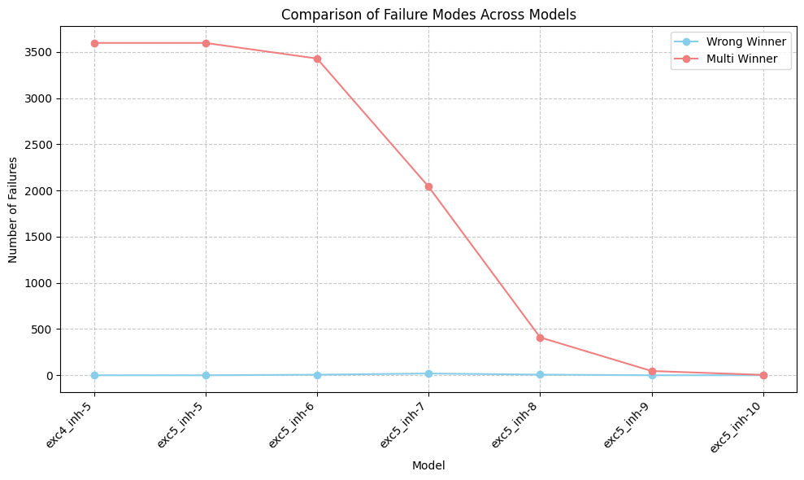

exc4_inh-5: frac_correct=0.001, wrong_winner=0, multi_winner=3598
exc5_inh-5: frac_correct=0.001, wrong_winner=0, multi_winner=3598
exc5_inh-6: frac_correct=0.046, wrong_winner=6, multi_winner=3429
exc5_inh-7: frac_correct=0.427, wrong_winner=19, multi_winner=2042
exc5_inh-8: frac_correct=0.884, wrong_winner=7, multi_winner=410
exc5_inh-9: frac_correct=0.987, wrong_winner=0, multi_winner=46
exc5_inh-10: frac_correct=0.999, wrong_winner=1, multi_winner=4

Freq, duty parameter search
W_gg = 5, -8 (around the max performance)
best parameters: freq = 0.2, duty = 0.6
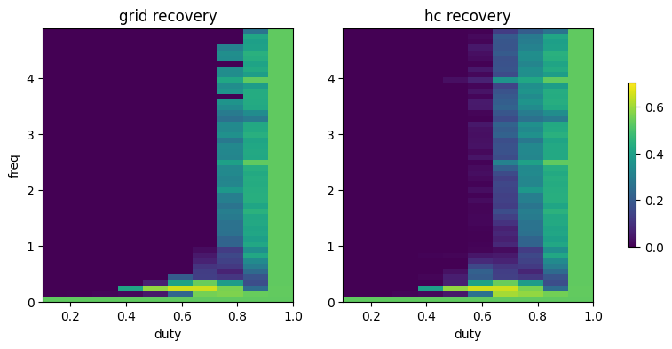

W_gg = 5, -8.75 (best performance with scaffold)
fraction correct changed from 0.458 to 0.459 – no improvement
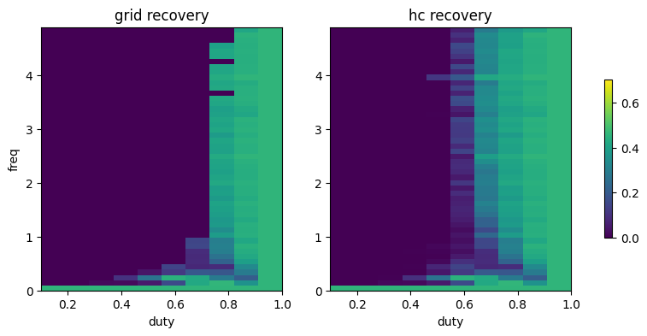

W_gg = 1, -5 (not robust to noise with grid)
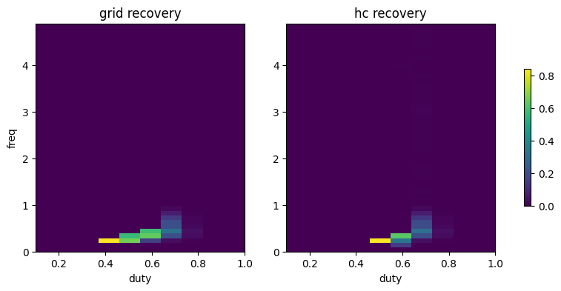
best parameters: freq=0.2, duty=0.4

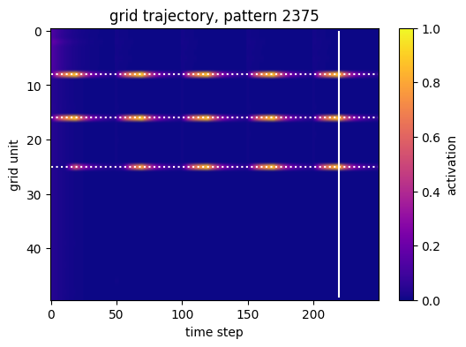
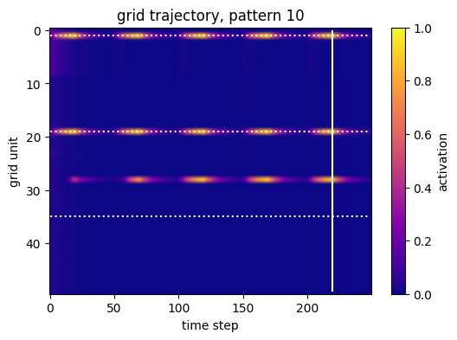

Two theta waves parameter search
freq_h_range = np.arange(0.0, 5.0, 0.5)
freq_g_range = np.arange(0.0, 5.0, 0.5)
duty_h_range = np.arange(0.1, 1.1, 0.2)
duty_g_range = np.arange(0.1, 1.1, 0.2)
phase_diff_range = np.arange(0.0, 1.1, 0.3)

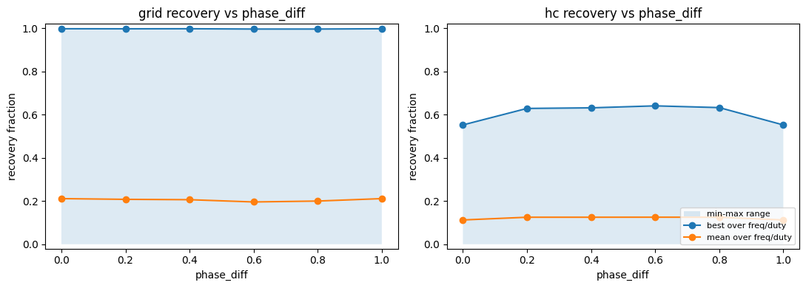
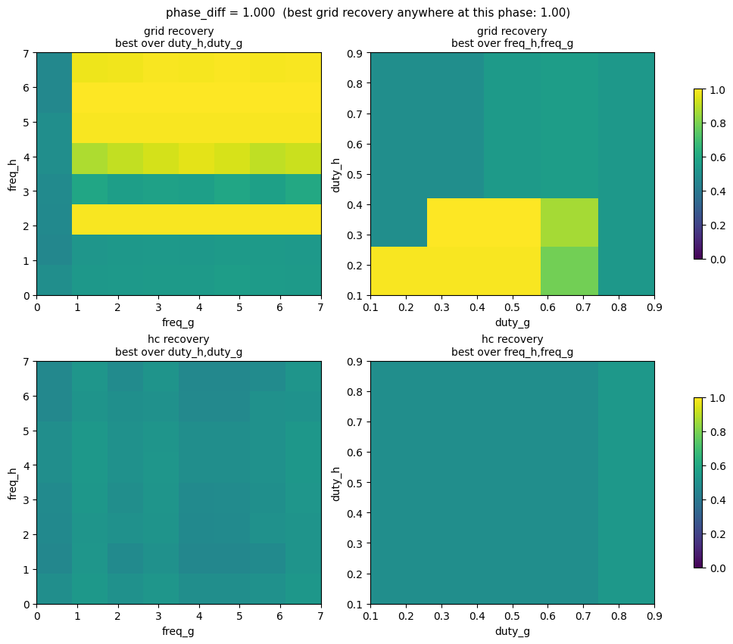

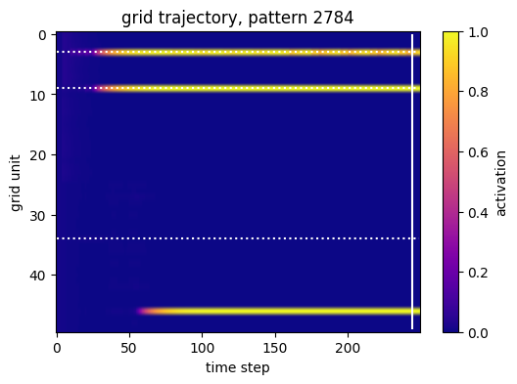
freq_h = 2
freq_g = 0.5
duty_h = 0.1
duty_g = 0.3
phase difference = 0
recovery fraction = 0.993!

best parameters for each phase value
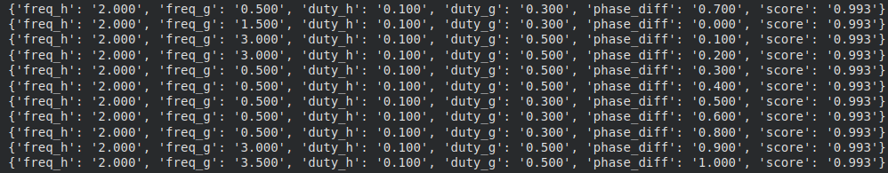
finer search:
